LAB N0. 15
Build a RAG-Based Chatbot Using Ollama and LangChain, and Streamlit
Lab Objective
By the end of this lab, students will be able to:
- Set up Ollama locally and run LLAMA2
- Build a basic LangChain chatbot using Ollama
- Implement document ingestion and vector storage
- Enable Retrieval-Augmented Generation (RAG)
- Deploy the chatbot using Streamlit

Tools & Technologies
- Python 3.9+
- VS Code
- Ollama (LLAMA2)
- LangChain
- Streamlit
- FAISS (Vector Store)
- Dotenv

File code 1
Localama.py
from langchain_openai import ChatOpenAI
from langchain_core.prompts import ChatPromptTemplate
from langchain_core.output_parsers import StrOutputParser
from langchain_community.llms import Ollama
import streamlit as st
import os
from dotenv import load_dotenv

load_dotenv()

os.environ["LANGCHAIN_TRACING_V2"]="true"
os.environ["LANGCHAIN_API_KEY"]=os.getenv("LANGCHAIN_API_KEY")

## Prompt Template

prompt=ChatPromptTemplate.from_messages(
[
("system","You are a helpful assistant. Please response to the user queries"),
("user","Question:{question}")
]
)
## streamlit framework

st.title('Langchain Demo With LLAMA2 API')
input_text=st.text_input("Search the topic u want")

# ollama LLAma2 LLm
llm=Ollama(model="llama2")
output_parser=StrOutputParser()
chain=prompt|llm|output_parser

if input_text:
st.write(chain.invoke({"question":input_text}))

Code File 2
App.py
from langchain_openai import ChatOpenAI
from langchain_core.prompts import ChatPromptTemplate
from langchain_core.output_parsers import StrOutputParser

import streamlit as st
import os
from dotenv import load_dotenv

os.environ["OPENAI_API_KEY"]=os.getenv("OPENAI_API_KEY")
## Langmith tracking
os.environ["LANGCHAIN_TRACING_V2"]="true"
os.environ["LANGCHAIN_API_KEY"]=os.getenv("LANGCHAIN_API_KEY")

## Prompt Template

prompt=ChatPromptTemplate.from_messages(
[
("system","You are a helpful assistant. Please response to the user queries"),
("user","Question:{question}")
]
)

## streamlit framework

st.title('Langchain Demo With OPENAI API')
input_text=st.text_input("Search the topic u want")

# openAI LLm
llm=ChatOpenAI(model="gpt-3.5-turbo")
output_parser=StrOutputParser()
chain=prompt|llm|output_parser

if input_text:
st.write(chain.invoke({'question':input_text}))

Step 1: Create Project Structure
Open VS Code and create the following folder structure:

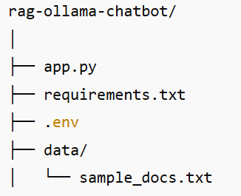

Step 2: Install and Verify Ollama
2.1 Install Ollama
Download and install Ollama from:

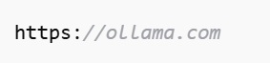
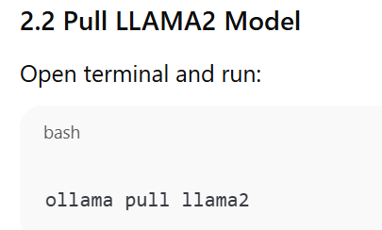

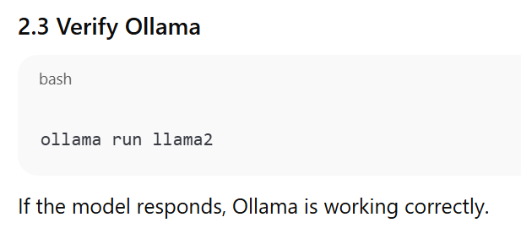

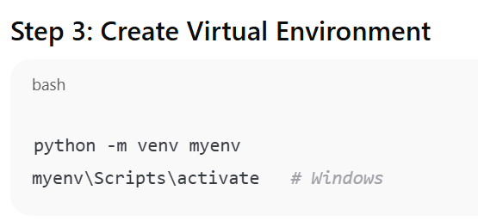
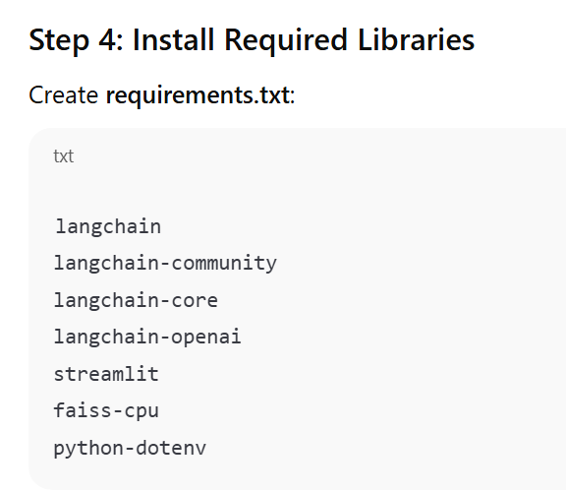
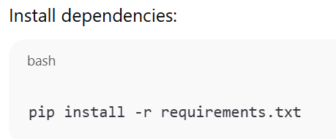
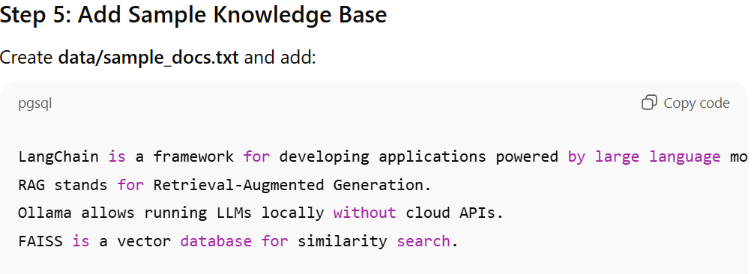
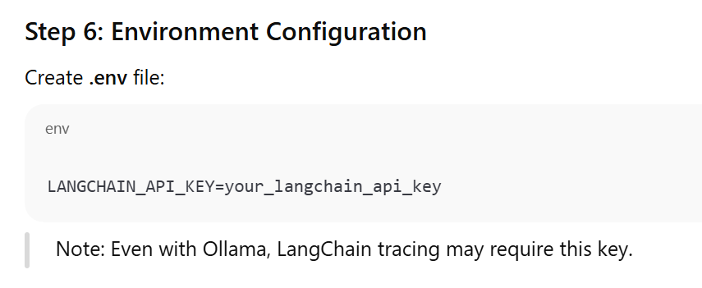
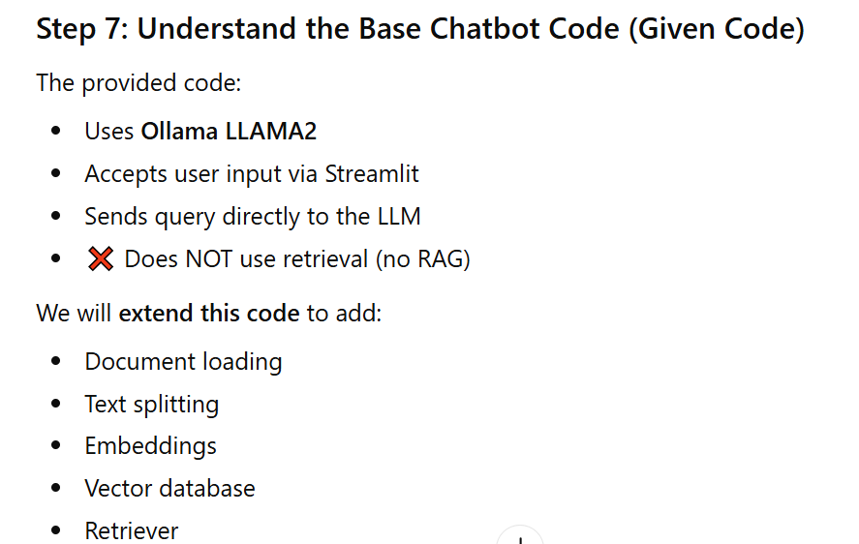

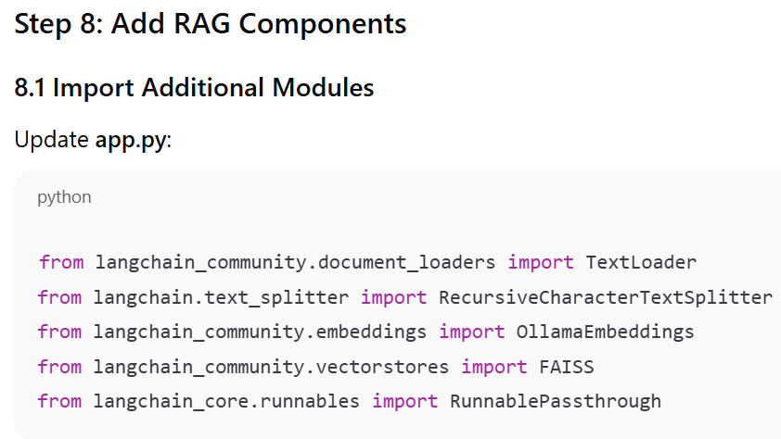
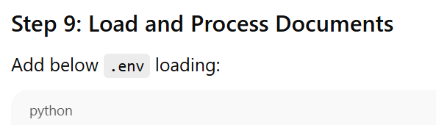
# Load documents
loader = TextLoader("data/sample_docs.txt")
documents = loader.load()

# Split documents
text_splitter = RecursiveCharacterTextSplitter(
chunk_size=500,
chunk_overlap=50
)
docs = text_splitter.split_documents(documents)

Step 10: Create Embeddings and Vector Store
# Create embeddings
embeddings = OllamaEmbeddings(model="llama2")

# Create FAISS vector store
vectorstore = FAISS.from_documents(docs, embeddings)

# Create retriever
retriever = vectorstore.as_retriever()

Step 11: Modify Prompt for RAG
Replace your prompt template with:
prompt = ChatPromptTemplate.from_messages(
[
("system", "Answer the question using the provided context only."),
("user", "Context:\n{context}\n\nQuestion:\n{question}")
]
)

Step 12: Build the RAG Chain
llm = Ollama(model="llama2")
output_parser = StrOutputParser()

rag_chain = (
{
"context": retriever,
"question": RunnablePassthrough()
}
| prompt
| llm
| output_parser
)

Step 13: Update Streamlit UI
st.title("RAG Chatbot with Ollama & LangChain")

input_text = st.text_input("Ask a question based on the documents")

if input_text:
response = rag_chain.invoke(input_text)
st.write(response)

Step 14: Run the Application
streamlit run app.py

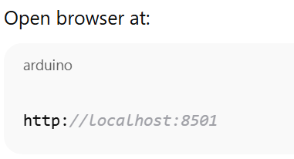

LAB Assessment

Student Name |  | LAB Rubrics | CLO3 , P5, PLO5
 |  | Total Marks | 10
Registration No |  | Obtained Marks
 |  | Teacher Name | Dr. Syed M Hamedoon
Date |  | Signature

